**INDIAN AGRICULTURE CROP PRODUCTION**

1.Introduction

1.1 Overview

This report delves into the captivating realm of India's agricultural cultivation, providing a comprehensive visual exploration of key aspects and trends in the agricultural sector. Through the visual representations, readers can gain valuable insights into crop production, seasonal variations, regional distribution, and overall production trends. These visualizations enable intuitive analysis, allowing stakeholders to uncover patterns, identify areas of growth or concern, and make data-driven decisions.

By harnessing the power of Tableau, this report not only presents the data in a visually appealing manner but also provides an interactive experience for readers to explore the intricacies of India's agricultural cultivation. To Extract the Insights from the data and put the data in the form of visualizations, Dashboards and Story we employed Tableau tool.

1.2 Purpose

The purpose of the Indian agriculture is foundation of the Indian economy. population of India mostly depend on agriculture for their livelihood and agriculture contributes 40 percentage of the total GDP of the country.

2. Problem Definition &Design Thinking

Problem understanding also known as problem definition or problem identification is the initial and critical phase of any data analysis or problem –solving process it involves gaining clear and comprehensive understanding of the problem at hand its context ,scope,and objective.

2.1 Empathy map

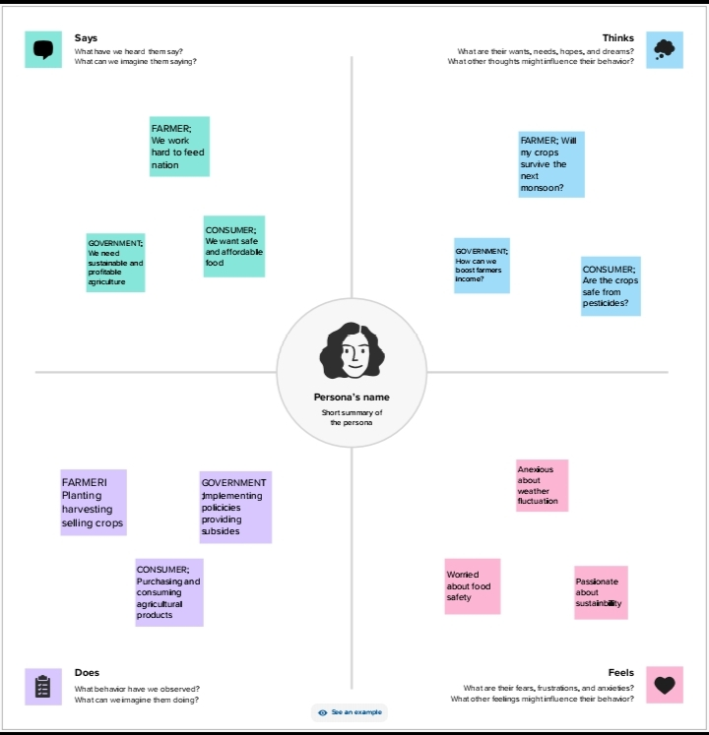

2.2 Brainstoming Map

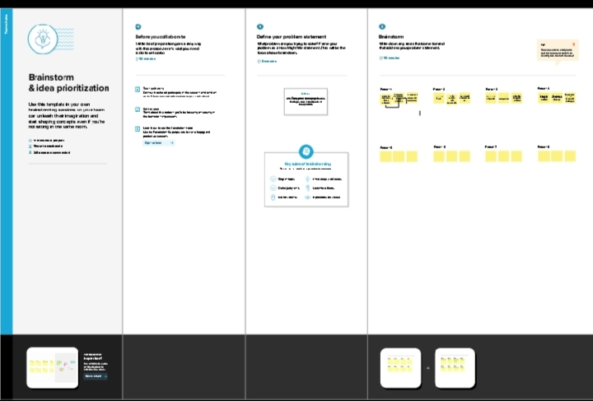

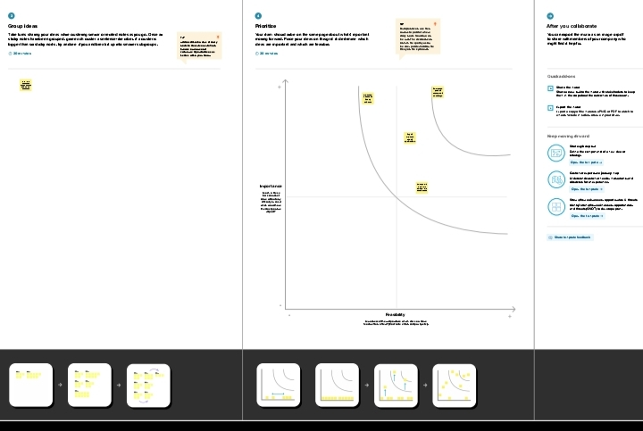

3.Result

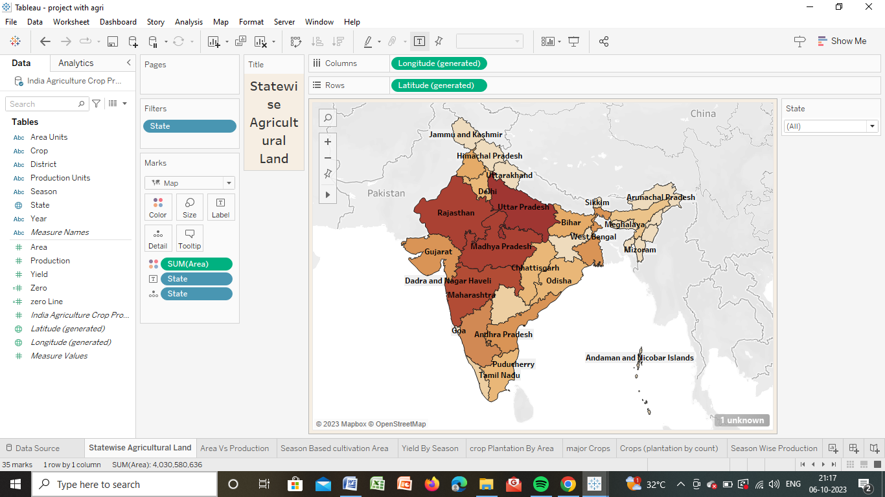

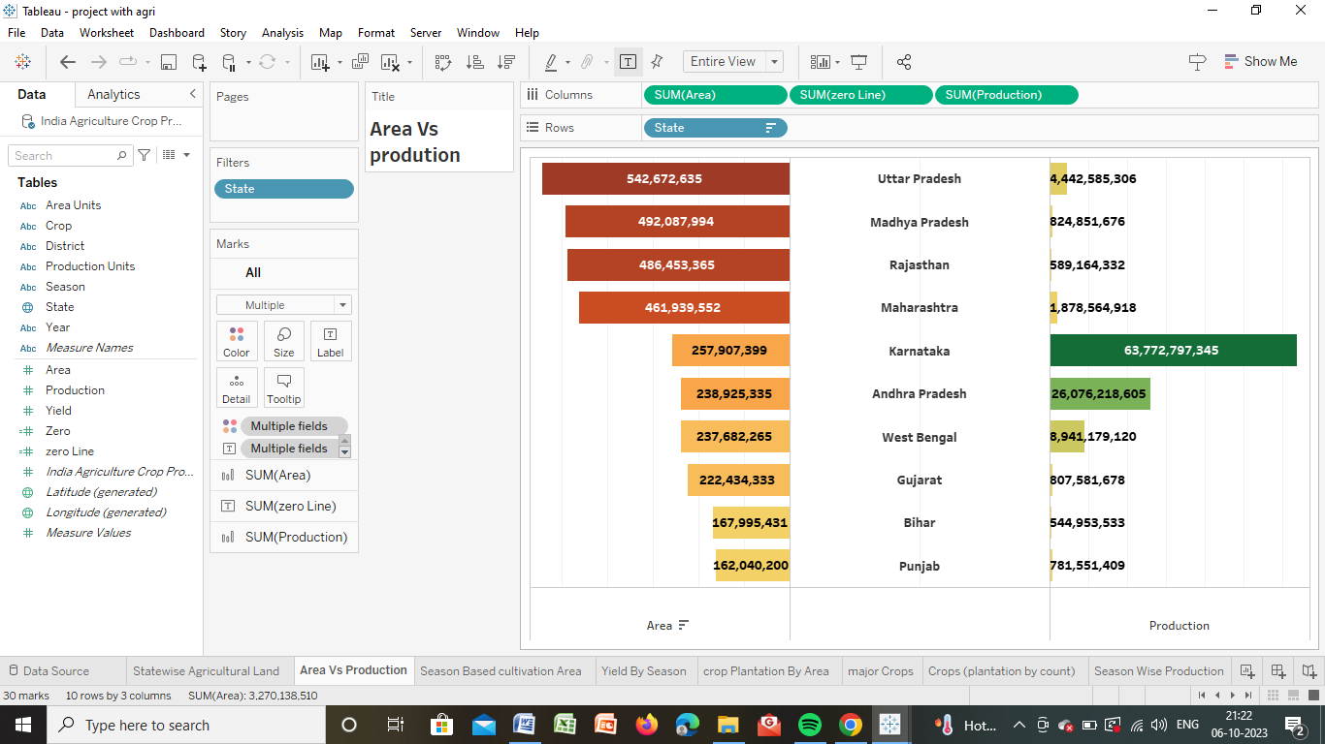

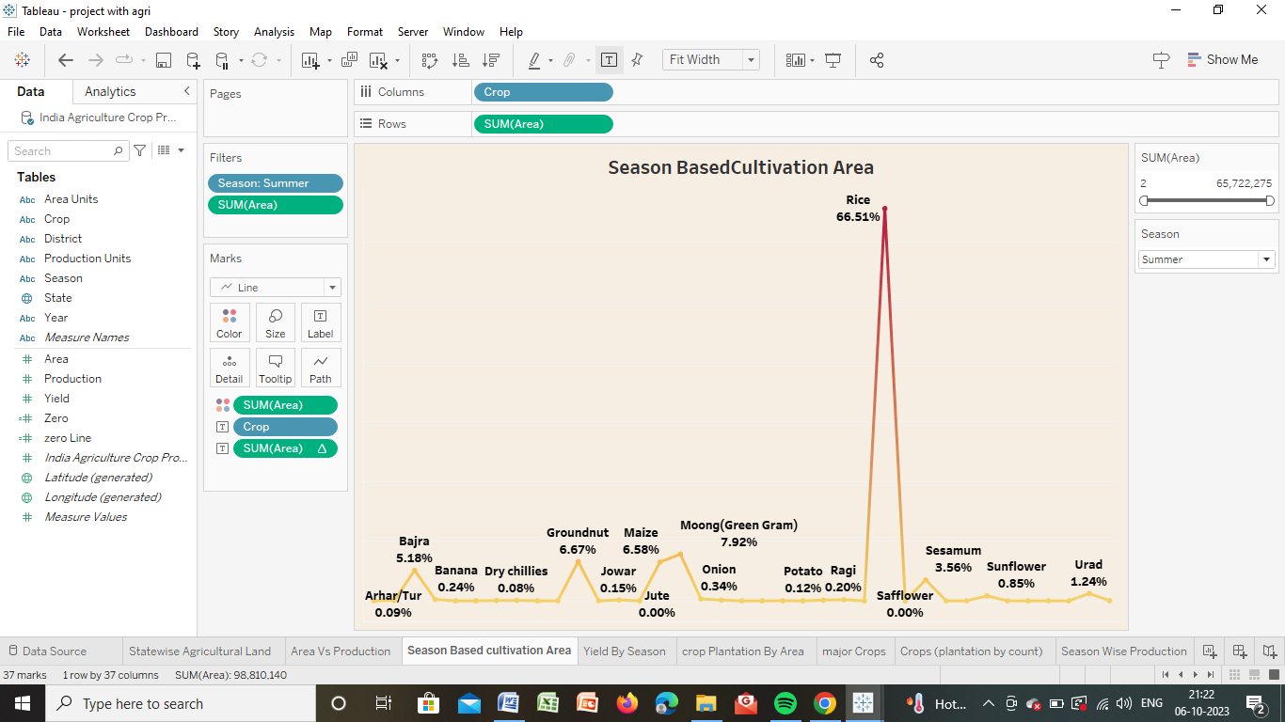

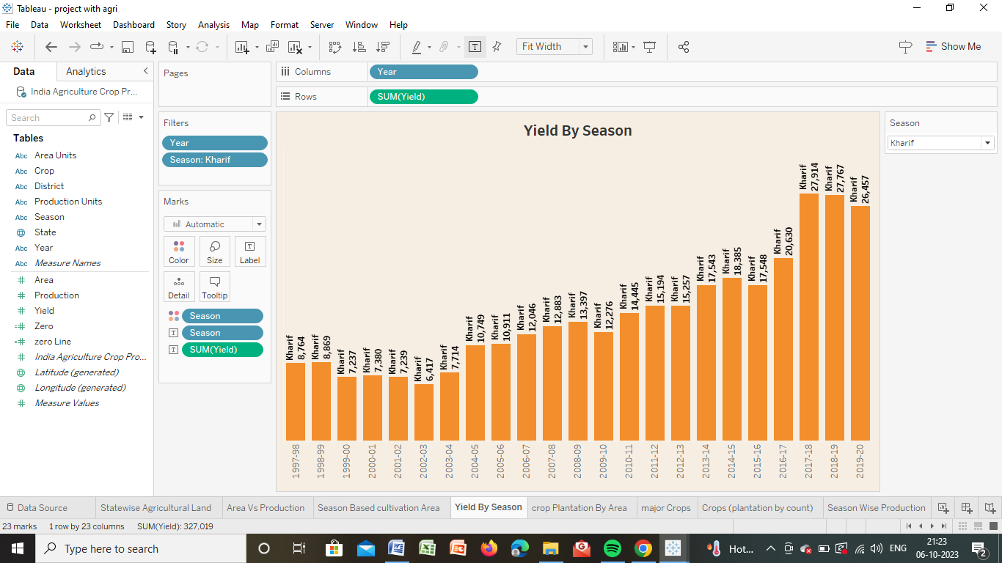

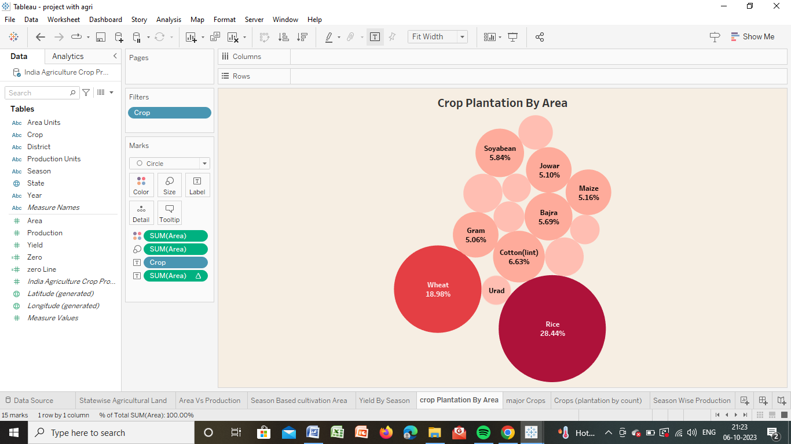

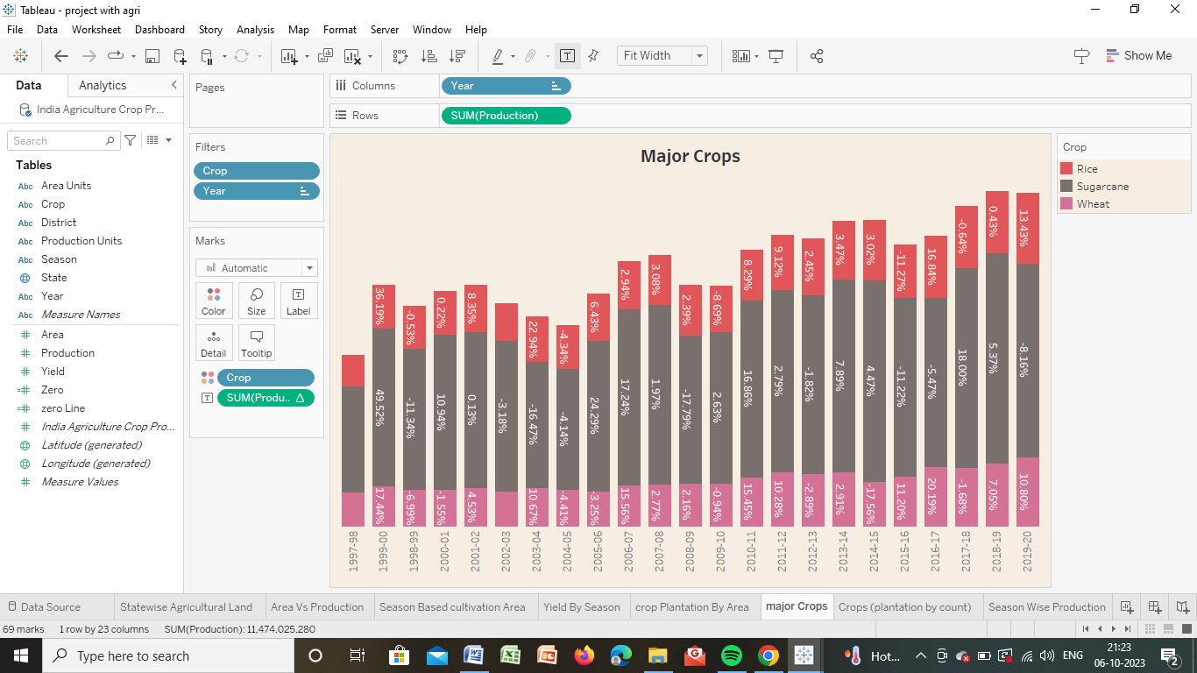

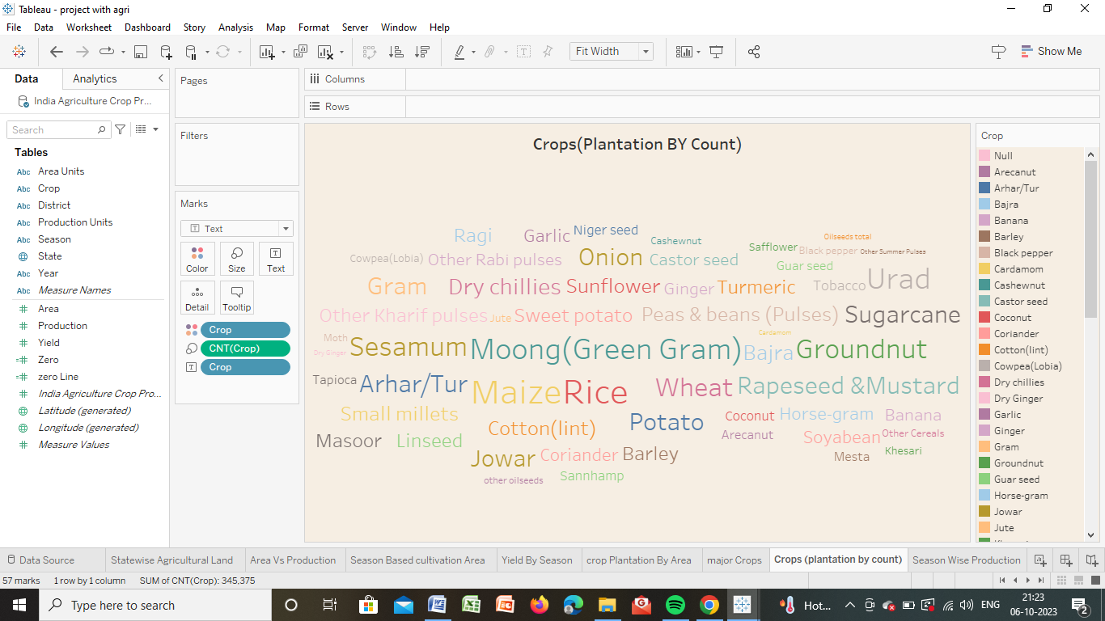

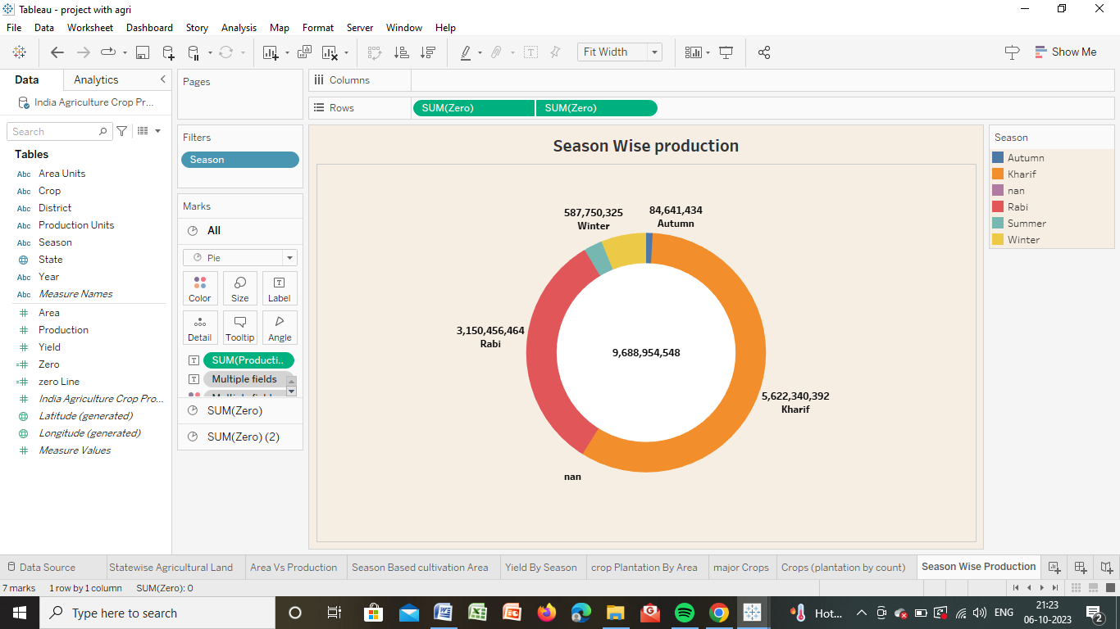

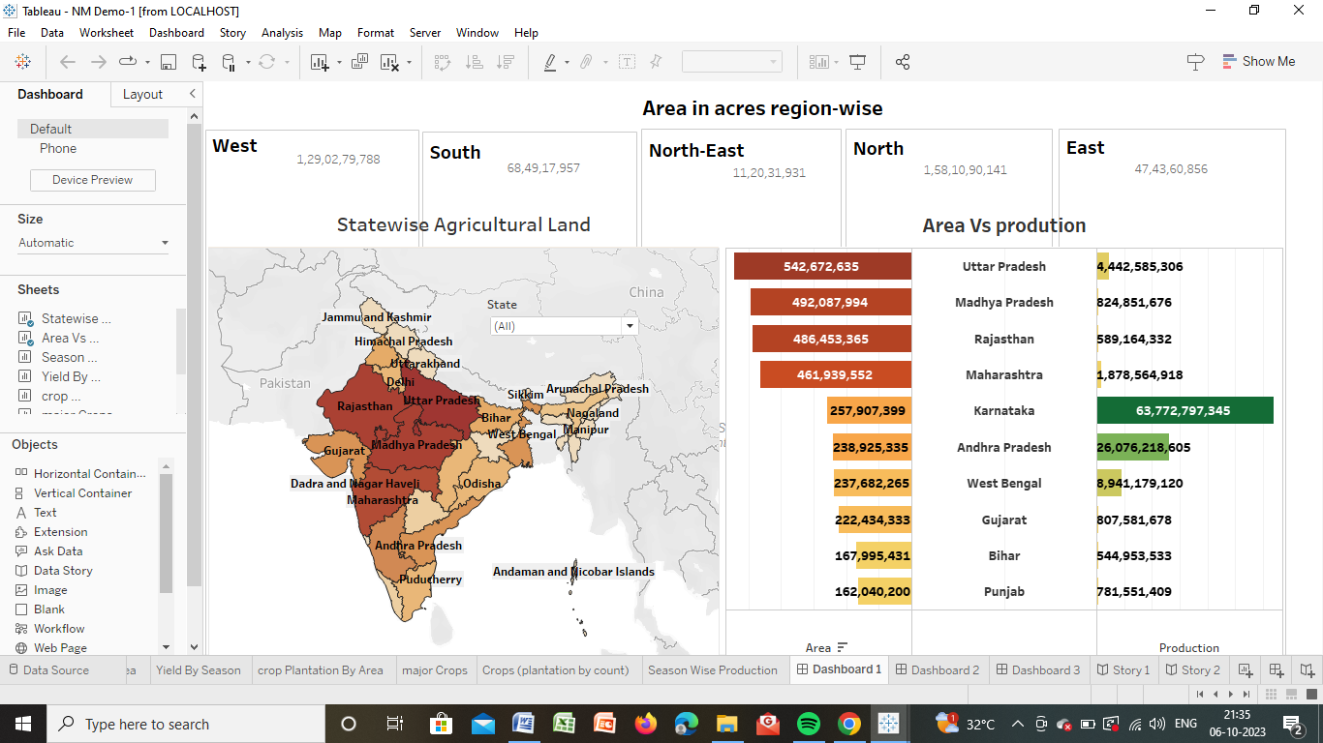

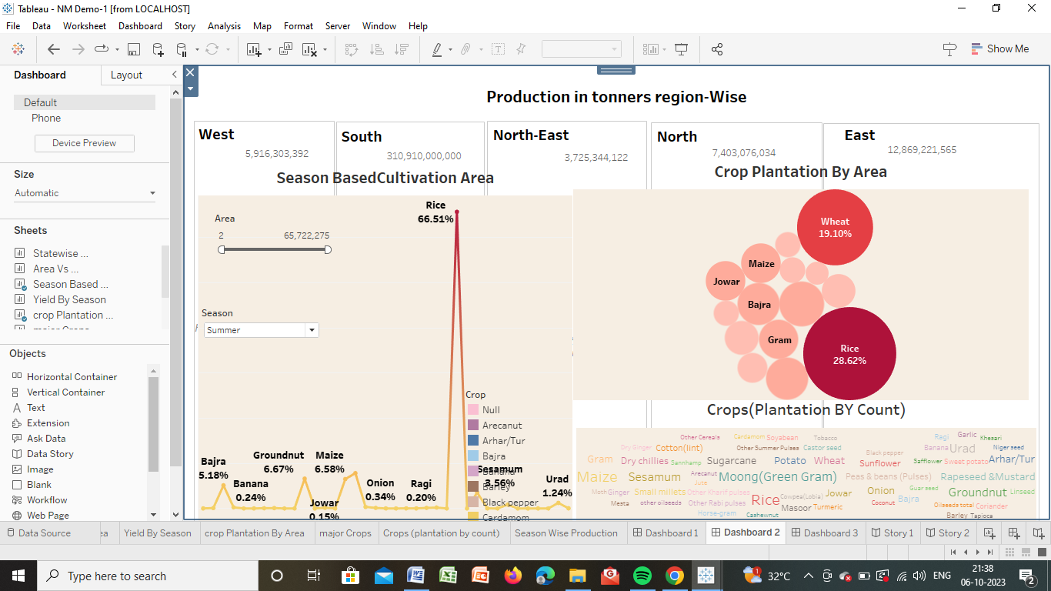

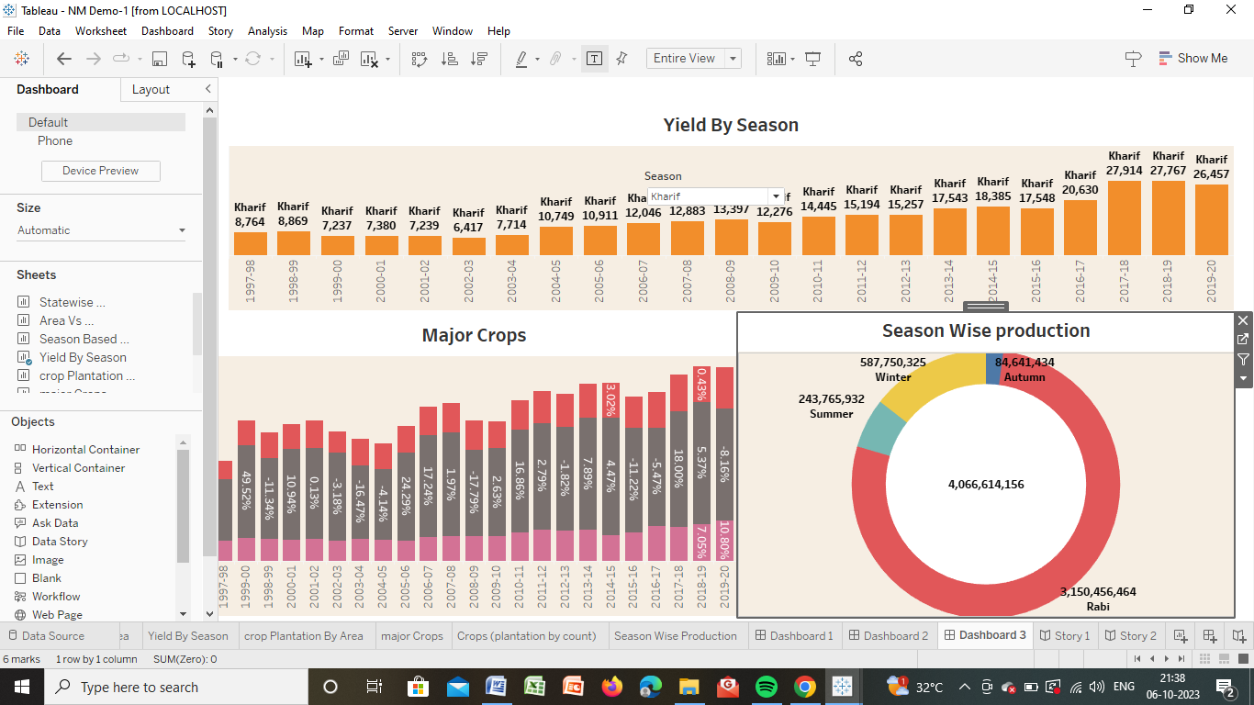

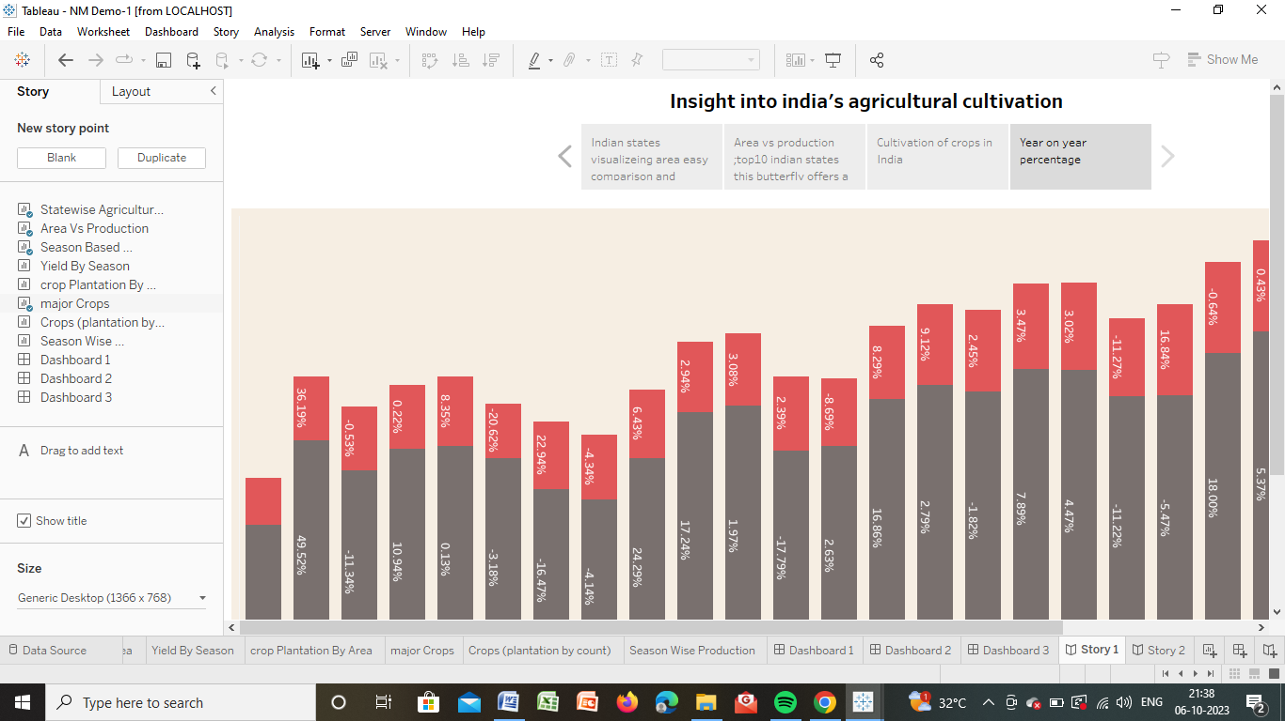

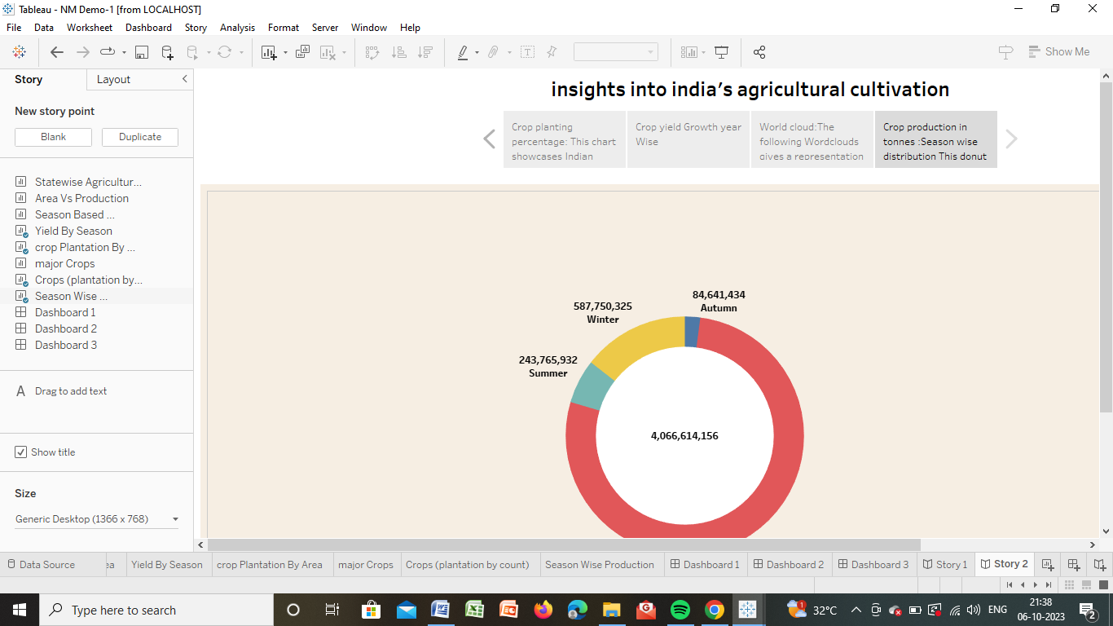

4.1 Advantages and Disadvantages

4.1 Advantages

* It reduces the risk of the failure of crops
* It enhance soil fertility
* It helps in saving farmers money
* Farmers can quickly meet their family requirements

4.2 Disadvantages

* Spreading fertilizers to individual crops is difficult
* It is consumed and marketed in a mixed form
* Guardian crops from animals Is a challenging task
* Threshing and harvesting crops separately are not possible

5.Applications

* Agriculture land monitoring
* Crop area estimation

6.Conculsion

The productivity in Indian agriculture has increased significantly in the period form from 1970-2013.Total production of food grains has increased from 108.42 million tones to 257.13 million tones during this period

7.Future Scope

As per the second advance the estimates for 2019-20 the total country food grain production is estimated to be a record 291.95 million tones

It may increase in future